WEEK 5 TASK: BUSINESS STRATEGY DEVELOPMENT AND RECOMMENDATION REPORT

1. Introduction
The Indian e-commerce industry is growing as more customers use online platforms to purchase products. Businesses in this industry face strong competition, changing customer expectations, pricing pressure, and increasing demand for convenient delivery services.
This report develops a business strategy for a hypothetical Indian e-commerce company that wants to improve its competitive position and customer satisfaction. The report uses situational analysis, market trends, and SWOT analysis to identify business challenges and opportunities.
The main objective is to recommend practical strategies that can help the company increase customer retention, improve operational efficiency, strengthen its market position, and achieve sustainable business growth. The report also includes data insights, strategic recommendations, implementation plans, and risk mitigation measures.

2. Business Background and Current Situation

2.1 Business Background
This report focuses on a hypothetical Indian e-commerce company named SmartShop India. The company sells products such as clothing, electronics, home accessories, and daily-use items through an online shopping platform. Its target customers include individuals living in urban and smaller cities across India.
The company aims to provide affordable products, convenient online shopping, reliable delivery, and good customer service. It operates in a competitive market where established platforms such as Amazon India, Flipkart, and Meesho attract customers through product variety, pricing, promotions, and delivery services.

2.2 Current Business Situation
SmartShop India faces several challenges that may affect its growth and profitability. These include strong competition, price-sensitive customers, delivery delays, customer retention difficulties, and increasing expectations for convenient digital shopping.
The company needs to understand customer behavior, market trends, operational performance, and competitor strategies before deciding how to improve its business position.

2.3 Key Business Challenges
The main challenges identified for SmartShop India are:
- Strong competition: Established e-commerce platforms make it difficult for a smaller company to attract and retain customers.
- Pricing pressure: Customers frequently compare prices and discounts across different platforms.
- Delivery performance: Delayed deliveries and order fulfilment problems can reduce customer satisfaction.
- Customer retention: Poor service or limited product choices may encourage customers to shop elsewhere.
- Technology and digital experience: The company needs a user-friendly platform, secure payments, and relevant product recommendations.

2.4 Business Opportunity
SmartShop India can improve its competitive position by focusing on selected product categories, offering reliable delivery, improving customer support, and providing a simple mobile shopping experience. Using sales and customer data can help the company identify popular products, understand customer preferences, and make better business decisions.

3. Market and Situational Analysis

3.1 Indian E-commerce Market Overview
India's e-commerce industry offers significant growth opportunities because of increasing internet access, digital payments, smartphone usage, and changing customer preferences. According to Deloitte and FICCI, India's online retail market was valued at approximately US$75 billion in 2024 and is projected to reach US$260 billion by 2030.
This growth creates opportunities for SmartShop India to attract new customers, expand its product range, and improve its online shopping services.

3.2 Key Market Trends
The following trends are important for SmartShop India:
- Growth in online shoppers: India had approximately 290–300 million online shoppers in 2025, according to the India Brand Equity Foundation (IBEF). This indicates a substantial customer base for online retailers.
- Growth in smaller cities: Tier-2 and smaller cities are contributing significantly to new online shoppers, creating opportunities to reach customers beyond major metropolitan areas.
- Digital payments: Digital payment methods such as UPI make online transactions convenient and support the growth of e-commerce.
- Quick commerce: Customers increasingly value convenient and fast delivery. Businesses must assess delivery expectations and costs before introducing faster delivery services.
- Personalized shopping: Product recommendations and digital discovery tools create opportunities to improve product discovery and customer engagement.

3.3 Situational Analysis of SmartShop India
Based on the hypothetical business scenario, SmartShop India needs to improve its competitiveness while managing operational costs.
Its main challenges are competition from established marketplaces, price-sensitive customers, delivery performance, and customer retention. Its opportunities include targeting underserved customer groups, improving customer service, strengthening its mobile shopping experience, and using sales data to identify popular products.

3.4 Key Business Insights
The market analysis suggests three strategic priorities:
- Customer experience: Improve order tracking, customer support, and the returns process.
- Targeted growth: Focus on selected product categories and customer groups rather than competing with every large marketplace on price.
- Data-driven decisions: Monitor sales, customer satisfaction, repeat purchases, delivery times, and product returns to evaluate business performance.
These priorities will guide the SWOT analysis and strategy development in the next sections.

4. Data Analysis and Key Insights

4.1 Data Requirements
The company should collect and analyze business data to understand its performance and identify opportunities for improvement. The following key performance indicators (KPIs) can help SmartShop India make informed decisions.
KPI | Purpose
Total Sales | Measures revenue generated from product sales.
Number of Orders | Measures customer purchasing activity.
Average Order Value | Shows the average amount spent per order.
Customer Retention Rate | Measures how effectively the company retains customers.
On-Time Delivery Rate | Measures delivery of reliability.
Product Return Rate | Identifies possible product or service problems.
These indicators should be reviewed regularly to identify trends, monitor business performance, and support strategic decisions.

4.2 Create a sales chart in Excel
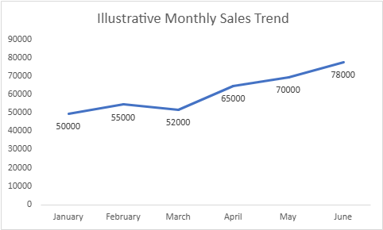
Figure 1: Illustrative Monthly Sales Trend for SmartShop India

4.3 Data Insights and Business Implications
The illustrative sales data show an overall upward trend from January to June, although sales decreased slightly in March. If a similar pattern appeared in actual company data, the Business Analyst should investigate possible reasons for the monthly decline and identify the factors contributing to growth in later months.
SmartShop India should compare sales performance across product categories, regions, and customer segments. It should also examine delivery performance, repeat purchases, and product returns. These analyses can help the company identify profitable products, improve customer satisfaction, and allocate resources effectively.
Before making final business decisions, the company must validate its actual sales records and investigate the reasons behind the observed trends.

5. SWOT Analysis
SWOT analysis is a strategic planning technique used to evaluate internal strengths and weaknesses and external opportunities and threats. It helps SmartShop India understand its competitive position and develop suitable business strategies.

5.1 SWOT Analysis of SmartShop India
Strengths | Weaknesses
Flexible business operations and decision-making. | Lower brand recognition than established competitors.
Ability to focus on selected product categories. | Limited resources for advertising and technology development.
Opportunity to provide personalized customer service. | Limited customer data and operating history.
Potential to adapt quickly to customer feedback. | Dependence on third-party delivery providers.

Opportunities | Threats
Growth in online shopping across India. | Strong competition from Amazon India, Flipkart, and Meesho.
Increasing the adoption of digital payments. | Price competition and frequent discount campaigns.
Potential to attract customers in smaller cities. | Rising delivery, marketing, and operating costs.
Use customer data to improve product recommendations. | Negative customer reviews are caused by poor service or delivery delays.

5.2 SWOT Analysis Discussion
SmartShop India's potential strengths include flexibility, focused product selection, and the ability to respond to customer feedback. However, its limited brand recognition and resources may make it difficult to compete directly with large e-commerce platforms.
The growth of online shopping and digital payments creates opportunities to reach new customers. At the same time, strong competition, pricing pressure, and rising operating costs could affect profitability.
Therefore, SmartShop India should avoid competing only through discounts. Instead, it should focus on selected product categories, reliable delivery, responsive customer service, and a convenient shopping experience.

5.3 Strategic Implications
The SWOT analysis suggests three priorities for SmartShop India:
- Use strengths: Build customer relationships through responsive service and a focused product range.
- Address weaknesses: Improve brand awareness gradually and invest in essential technology and customer support.
- Manage threats: Monitor competitors, control operating costs, and measure customer satisfaction regularly.
These priorities will form the foundation for the business strategy developed in the next section.

5.4 Create a SWOT diagram
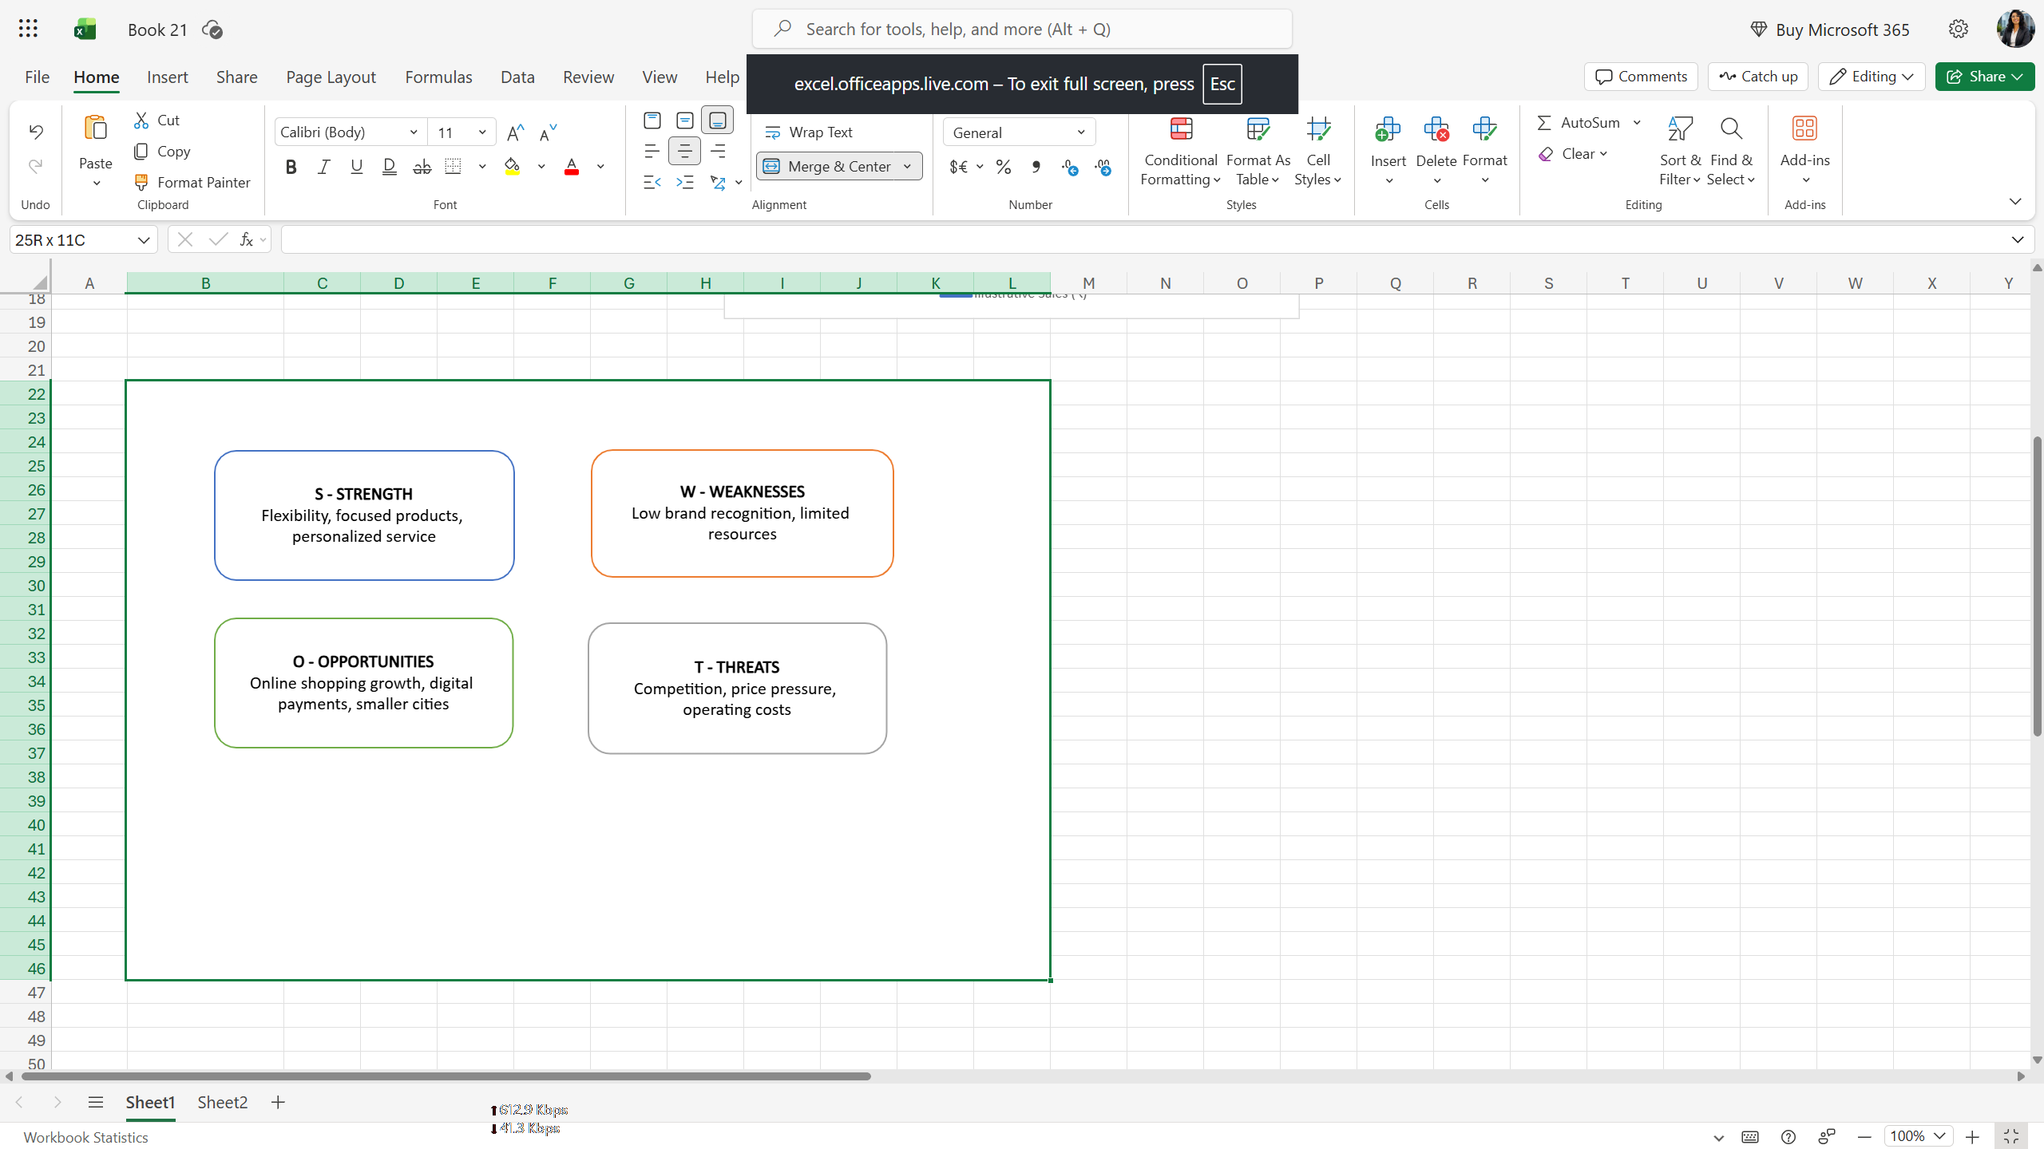
Figure 2: SWOT Analysis of SmartShop India

6. Business Strategy Formulation

6.1 Proposed Business Strategy
SmartShop India will adopt a customer-focused differentiation strategy. Instead of competing directly with large e-commerce platforms on price alone, the company will focus on reliable delivery, responsive customer service, carefully selected products, and a convenient online shopping experience.
This strategy aims to build customer trust, encourage repeat purchases, and improve long-term business performance.

6.2 Strategic Pillars
1. Improve Customer Experience
The company will improve order tracking, provide timely delivery updates, simplify returns, and respond quickly to customer complaints. These improvements can help build customer trust and encourage repeat purchases.
2. Focus on Selected Product Categories
SmartShop India will identify product categories with promising demand and suitable profit margins. Sales data, customer feedback, and product return information will guide product selection and inventory decisions.
3. Strengthen Digital Marketing
The company will use social media, targeted advertising, and relevant product recommendations to increase brand awareness. Marketing campaigns will be evaluated using measures such as conversion rate, customer acquisition cost, and repeat purchase rate.
4. Improve Operational Efficiency
The company will monitor order processing time, delivery performance, inventory availability, and return rates. Working with reliable delivery partners and improving inventory planning may help reduce delays and unnecessary costs.
5. Use Data for Decision-Making
Management will review sales trends, customer feedback, product performance, and marketing results regularly. These insights will support better decisions about pricing, promotions, inventory, and customer retention.

6.3 Strategic Objectives
SmartShop India will pursue the following objectives over an initial six-month implementation period:
- Improve customer satisfaction through better service and order communication.
- Increase repeat purchases by strengthening customer retention activities.
- Improve on-time delivery performance by monitoring delivery partners.
- Reduce avoidable product returns by improving product descriptions and quality checks.
- Improve marketing efficiency by evaluating campaign performance and customer acquisition costs.
Specific numerical targets should be established after the company collects baseline performance data. This will help ensure that the targets are realistic and measurable.

7. Actionable Business Recommendations
Based on the market analysis and SWOT findings, the following recommendations are proposed to improve SmartShop India's competitiveness, customer satisfaction, and operational efficiency.

7.1 Recommendation 1: Improve Customer Service
SmartShop India should establish a structured customer support process to respond to customer questions, complaints, delivery issues, and return requests. The company should provide clear order updates and monitor customer feedback regularly.
Expected benefit: Improved customer trust, satisfaction, and repeat purchases.
Performance measure: Customer satisfaction score and average complaint resolution time.

7.2 Recommendation 2: Strengthen Digital Marketing
The company should use social media marketing, targeted advertising, and relevant product recommendations to reach potential customers. Marketing campaigns should focus on selected customer groups and product categories.
Expected benefit: Increased brand awareness and more qualified website visitors.
Performance measure: Website conversion rate and customer acquisition cost.

7.3 Recommendation 3: Improve Delivery Performance
SmartShop India should monitor delivery partners, track delayed orders, and establish a process for communicating delivery problems to customers. The company should review delivery performance regularly and address recurring issues with its logistics partners.
Expected benefit: More reliable deliveries and fewer customer complaints.
Performance measure: On-time delivery rate and delivery-related complaint rate.

7.4 Recommendation 4: Optimize Product Selection and Inventory
The company should analyze sales records, product demand, return rates, and profit margins to identify suitable products. Inventory should be reviewed regularly to reduce stock shortages and avoid holding excessive quantities of slow-moving products.
Expected benefit: Better product availability and more efficient use of working capital.
Performance measure: Stockout rate, inventory turnover, and product return rate.

7.5 Recommendation 5: Introduce Data-Driven Performance Reviews
Management should prepare a monthly dashboard showing sales, order volume, customer retention, delivery performance, and marketing results. These indicators should be compared against established targets to identify problems and improvement opportunities.
Expected benefit: Better business decisions and earlier identification of operational issues.
Performance measure: Monthly KPI review completion and progress against approved targets.

7.6 Recommendation Summary
SmartShop India should prioritize customer service and delivery reliability first, followed by targeted marketing, inventory optimization, and regular performance reviews. This approach allows the company to address customer-facing problems while building a stronger foundation for sustainable growth.
The recommendations should be introduced gradually, with responsibilities assigned to relevant team members and results reviewed against baseline data.

8. Implementation Plan and Timeline

8.1 Implementation Approach
SmartShop India will implement the proposed business strategy over six months. The work will be divided into phases to help the company manage resources, monitor progress, and evaluate results. The timeline is proposed for planning purposes and should be adjusted based on available resources.

8.2 Six-Month Implementation Plan
Timeline | Key Activities | Responsible Team | Expected Outcome
Month 1 | Collect baseline data, review customer complaints, and identify major delivery issues. | Business Analyst and Operations Team | A clear understanding of current performance.
Month 2 | Improve customer support procedures and order communication. | Customer Service Team | More consistent customer support.
Month 3 | Review delivery partners and establish delivery performance monitoring. | Operations and Logistics Teams | Better visibility of delivery issues.
Month 4 | Launch targeted digital marketing campaigns for selected products and customer groups. | Marketing Team | Improved brand awareness and campaign measurement.
Month 5 | Analyze product demand, stock availability, returns, and profit margins. | Inventory and Data Analysis Teams | Better product and inventory decisions.
Month 6 | Review KPIs, evaluate results, and recommend further improvements. | Management and Business Analyst | Performance review and next-stage action plan.

8.3 Key Performance Indicators
The following KPIs should be monitored throughout implementation:
- Customer satisfaction score: Measures customer experience.
- Customer retention rate: Measures how effectively the company retains customers.
- On-time delivery rate: Measures delivery reliability.
- Customer acquisition cost: Measures the cost of acquiring a new customer.
- Product return rate: Measures the proportion of orders or products returned, using a consistent definition.
- Sales revenue: Measures revenue generated during the reporting period.
During Month 1, the company should establish baseline values for these KPIs. Management can then approve realistic improvement of targets based on actual performance, available resources, and business priorities.

8.4 Monitoring and Evaluation
The Business Analyst should prepare a monthly performance report using data from sales, customer service, marketing, inventory, and delivery operations. The report should compare actual results with approved targets and explain significant changes.
If a KPI does not meet its target, the responsible team should investigate the cause and agree on corrective actions. A formal review at the end of Month 6 should determine which initiatives should continue, change, or expand.
This phased approach will help SmartShop India implement its strategy in a controlled manner and evaluate whether the recommendations deliver the intended business benefits.

9. Risk Analysis and Mitigation Strategies

9.1 Introduction to Risk Analysis
Risk analysis helps SmartShop India identify potential problems that could affect the implementation of its business strategy. By identifying risks early and preparing mitigation measures, the company can reduce disruption, control costs, and improve the likelihood of achieving its business objectives.

9.2 Key Business Risks
Risk | Potential Impact | Mitigation Strategy
Strong Competitor Pressure | Customers may choose established platforms offering wider product ranges or discounts. | Focus on selected product categories, reliable service, and customer relationships rather than competing only on price.
Delivery Delays | Late orders may reduce customer satisfaction and increase complaints. | Monitor delivery partners, track delayed orders, and communicate delivery updates promptly.
Marketing Campaign Failure | Advertising expenses may not generate enough sales. | Test campaigns on a small scale, monitor customer acquisition cost, and invest in campaigns that perform well.
Inventory Management Problems | Stock shortages or excess inventory may lead to lost sales or higher costs. | Forecast demand using historical sales data and review inventory regularly.
Data Security and Privacy Issues | Unauthorized access to customer information could damage trust and create legal or financial consequences. | Restrict access to customer data, use secure systems, and follow applicable data protection requirements.
Limited Financial Resources | The company may be unable to implement every recommendation at once. | Prioritize high-impact, affordable initiatives and implement the strategy in phases.
Poor Customer Response | Customers may not respond positively to changes in services or marketing. | Collect customer feedback, test changes before wider implementation, and adjust based on results.

9.3 Risk Monitoring
SmartShop India should maintain a risk register that records each risk, its likelihood, potential impact, responsible owner, and mitigation action. The management team should review this register monthly during the six-month implementation period.
High-priority risks, such as delivery failures, security incidents, and serious customer complaints, should be escalated promptly rather than waiting for the monthly review.

9.4 Conclusion of Risk Analysis
Effective risk management will help SmartShop India implement its business strategy in a controlled and responsible manner. Regular monitoring, clear accountability, customer feedback, and data-driven decisions will help the company identify problems early and take corrective action.

10. Data Visualizations and Charts

10.1 Chart 1 — Monthly Sales Trend
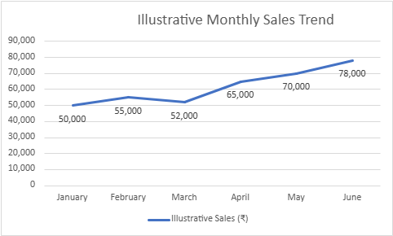
Figure 3: Illustrative Monthly Sales Trend for SmartShop India

10.2 Chart 2 — Strategic Priorities
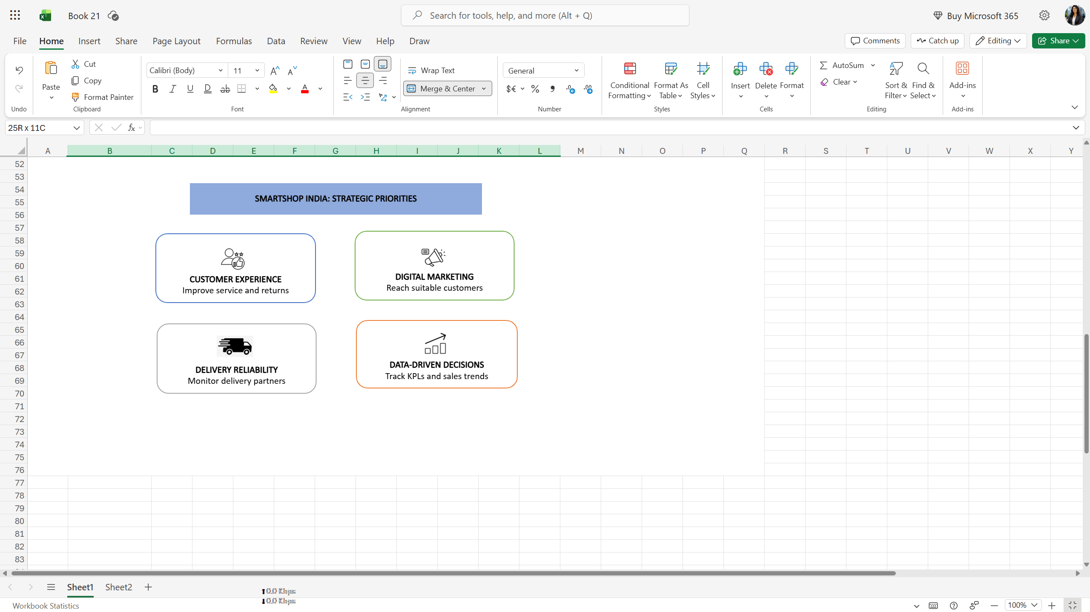
Figure 4: Strategic Priorities for SmartShop India

10.3 What to write under the visuals
The sales chart illustrates an overall increase in sample monthly sales, with a small decline in March. If similar patterns are observed in actual company data, management should investigate the reasons for monthly changes and identify the factors associated with sales growth.
The strategic priorities diagram summarizes the proposed focus areas for SmartShop India. Customer experience, digital marketing, delivery reliability, and data-driven decision-making are intended to support customer retention and sustainable business growth. Actual results should be evaluated using verified business data and established performance targets.

11. Conclusion
This report developed a business strategy for SmartShop India, a hypothetical e-commerce company operating in the competitive Indian online shopping market. The situational analysis identified important market trends, including the growth of online shopping, digital payments, and customer demand for convenient services.
The SWOT analysis highlighted potential strengths, weaknesses, opportunities, and threats affecting the company. Based on these findings, a customer-focused differentiation strategy was proposed to improve customer service, strengthen digital marketing, improve delivery reliability, optimize inventory, and support data-driven decision-making.
The report also presented actionable recommendations, a six-month implementation plan, key performance indicators, and risk mitigation strategies. The proposed charts demonstrate how sales data and strategic priorities can support business planning. The sales figures used in the illustrative chart are examples only and must not be treated as actual company results.
SmartShop India should establish baseline performance measurements, assign responsibilities, and review its progress regularly. By implementing the recommendations gradually and making decisions based on verified business data, the company can work toward improved customer satisfaction, operational efficiency, and sustainable business growth.

12. References
- Deloitte and FICCI. (2025). India's US$1.06 trillion retail sector is set to reach US$1.93 trillion by 2030.
https://www.deloitte.com/in/en/about/press-room/india-s-us-1-06-trillion-retail-sector-is-set-to-reach-1-93-trillion-by-2030.html
- India Brand Equity Foundation (IBEF). (n.d.). E-commerce Industry in India.
https://www.ibef.org/industry/ecommerce
- Deloitte. (2026). India's e-commerce market set to reach US$250 billion by 2030.
https://www.deloitte.com/in/en/about/press-room/indias-e-commerce-market-set-to-reach--250-billion-by-2030.html
- Google. (n.d.). E-commerce and the future of retail in India.
https://business.google.com/in/think/future-of-marketing/e-commerce-retail-future-india/
- Own analysis. (2026). SWOT Analysis and Business Strategy for SmartShop India. Prepared for this assignment.
- Own illustrative data. (2026). Monthly Sales Trend for SmartShop India. Sample data prepared for demonstration purposes only.

